As Cloud Engineers, in our company Penguin Corporation, we are responsible for infrastructure of our apps in AWS.

Our team is working on a new application, and we have to provide a web server in EC2 plus a way to serve static files from S3.

What is expected from us is to provide a working url which leads to example web server page like this one, and also a url serving a static image of the company’s talisman - penguin.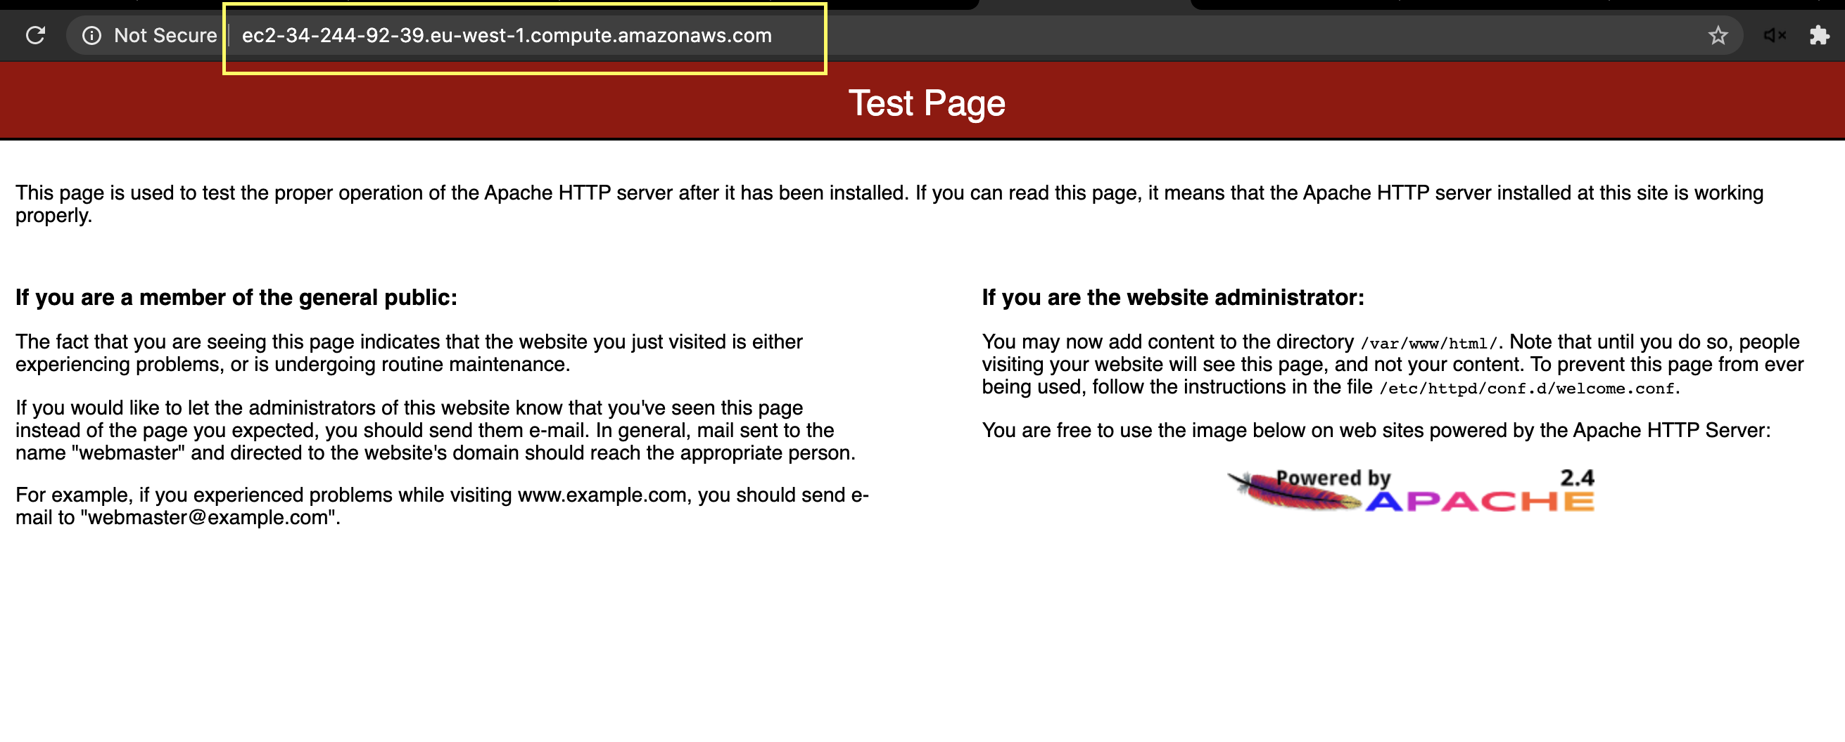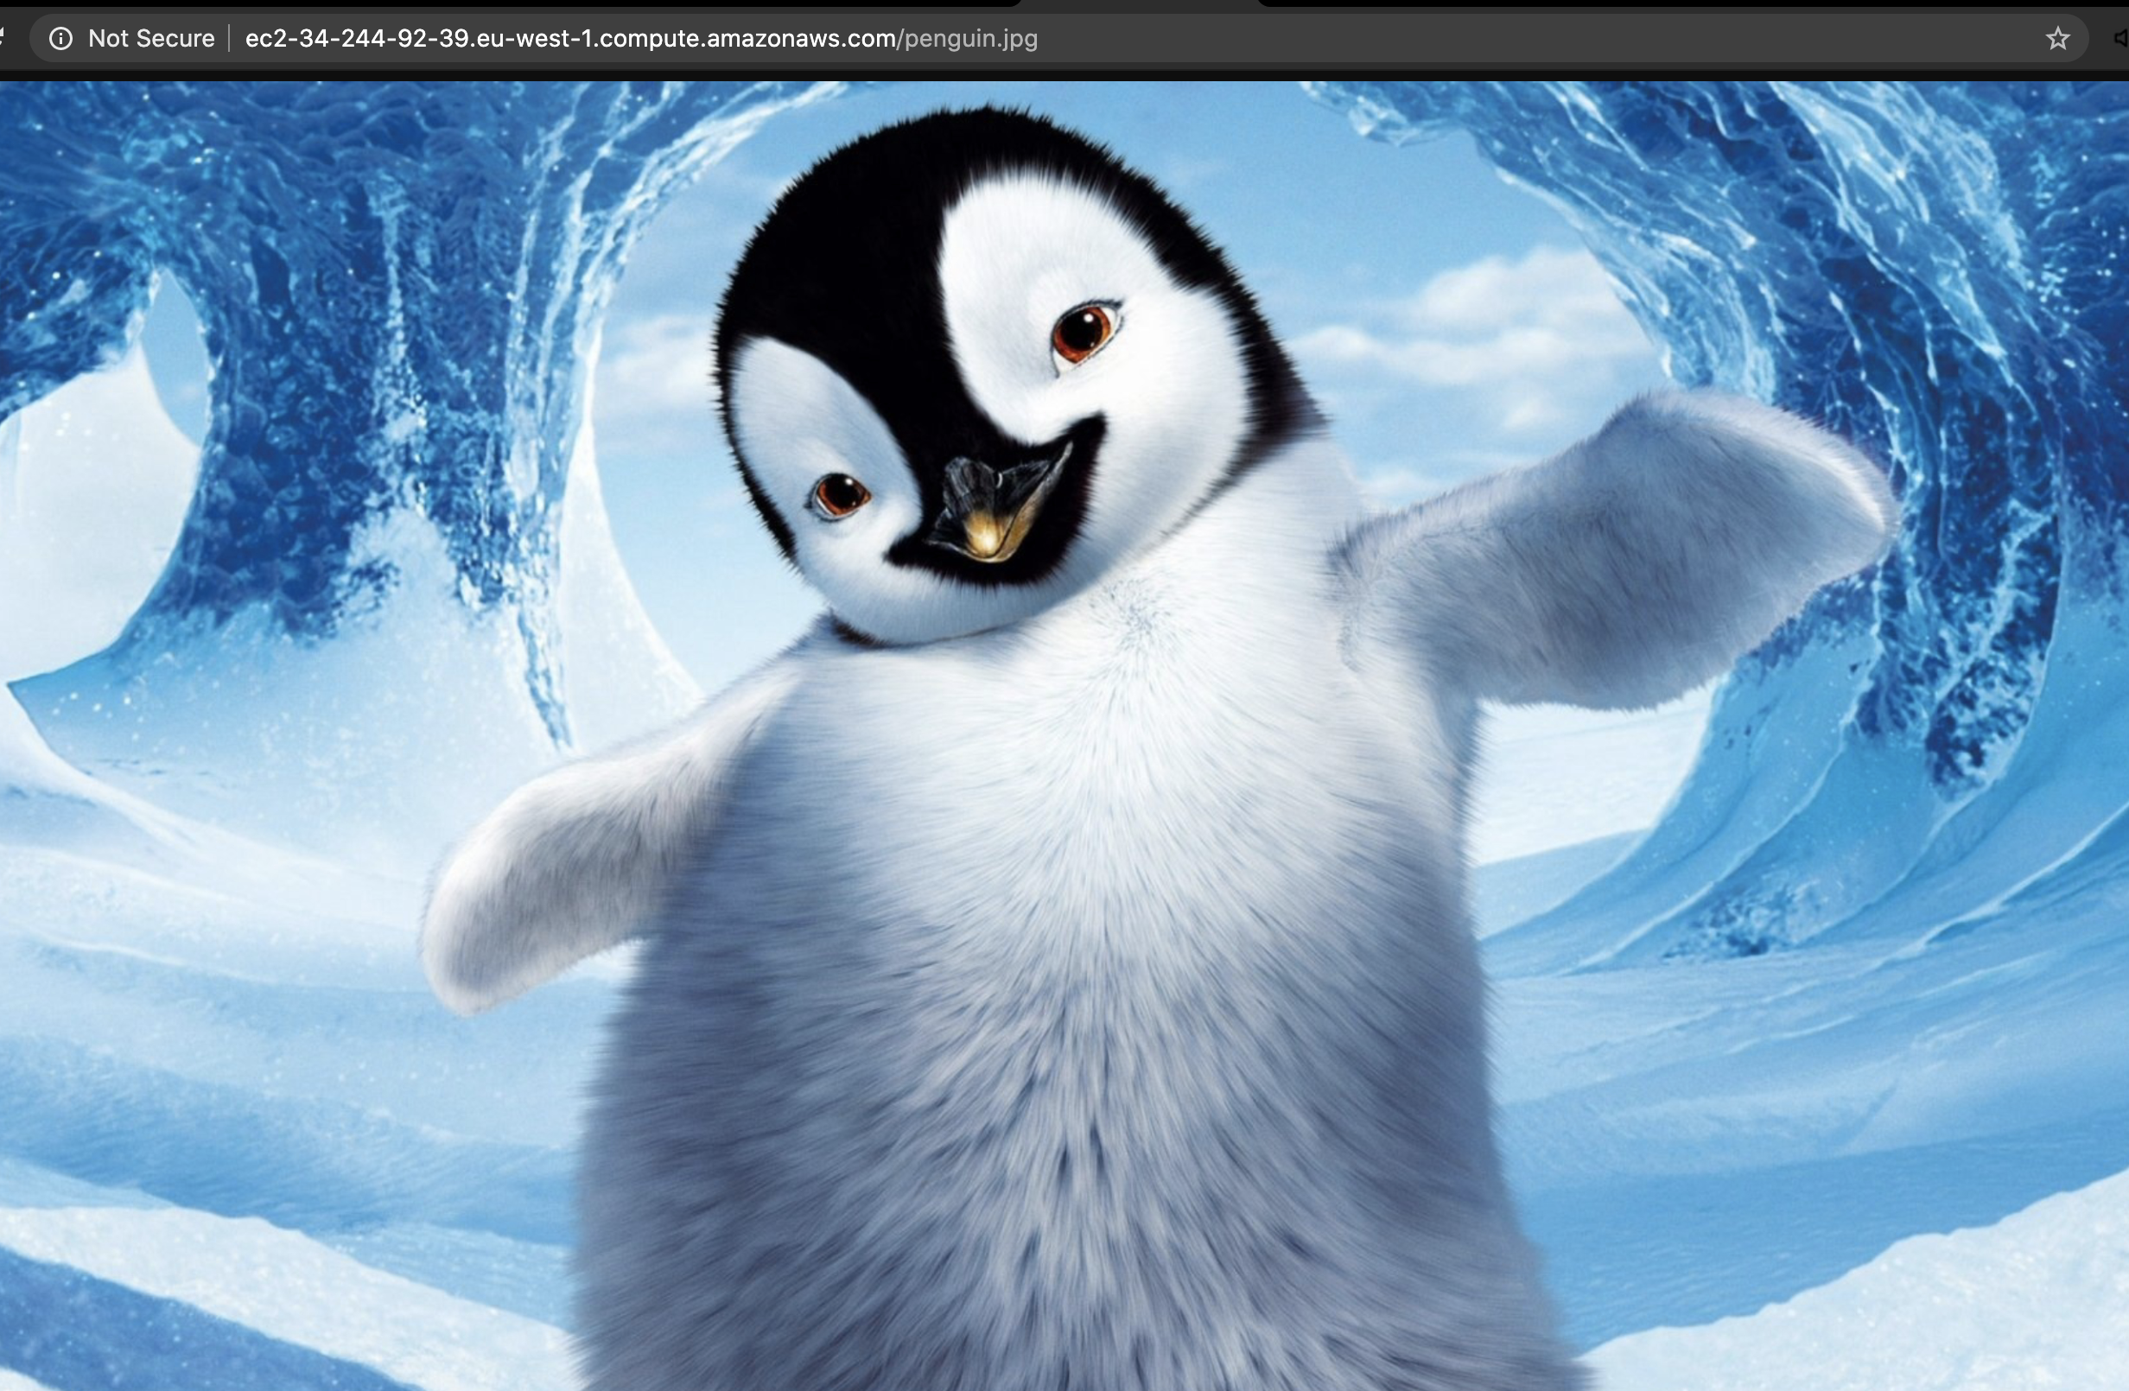

Our company’s architect gave us a few tips how to do the task :

1. First create S3 bucket in London Region
2. Find a penguin .jpg picture and upload to S3 - !!! Name the picture penguin.jpg !!! -This will be checked in the URL, it will not work if you don’t name the picture like that.
3. Go to IAM service and create a new Role with AmazonS3FullAccess policy

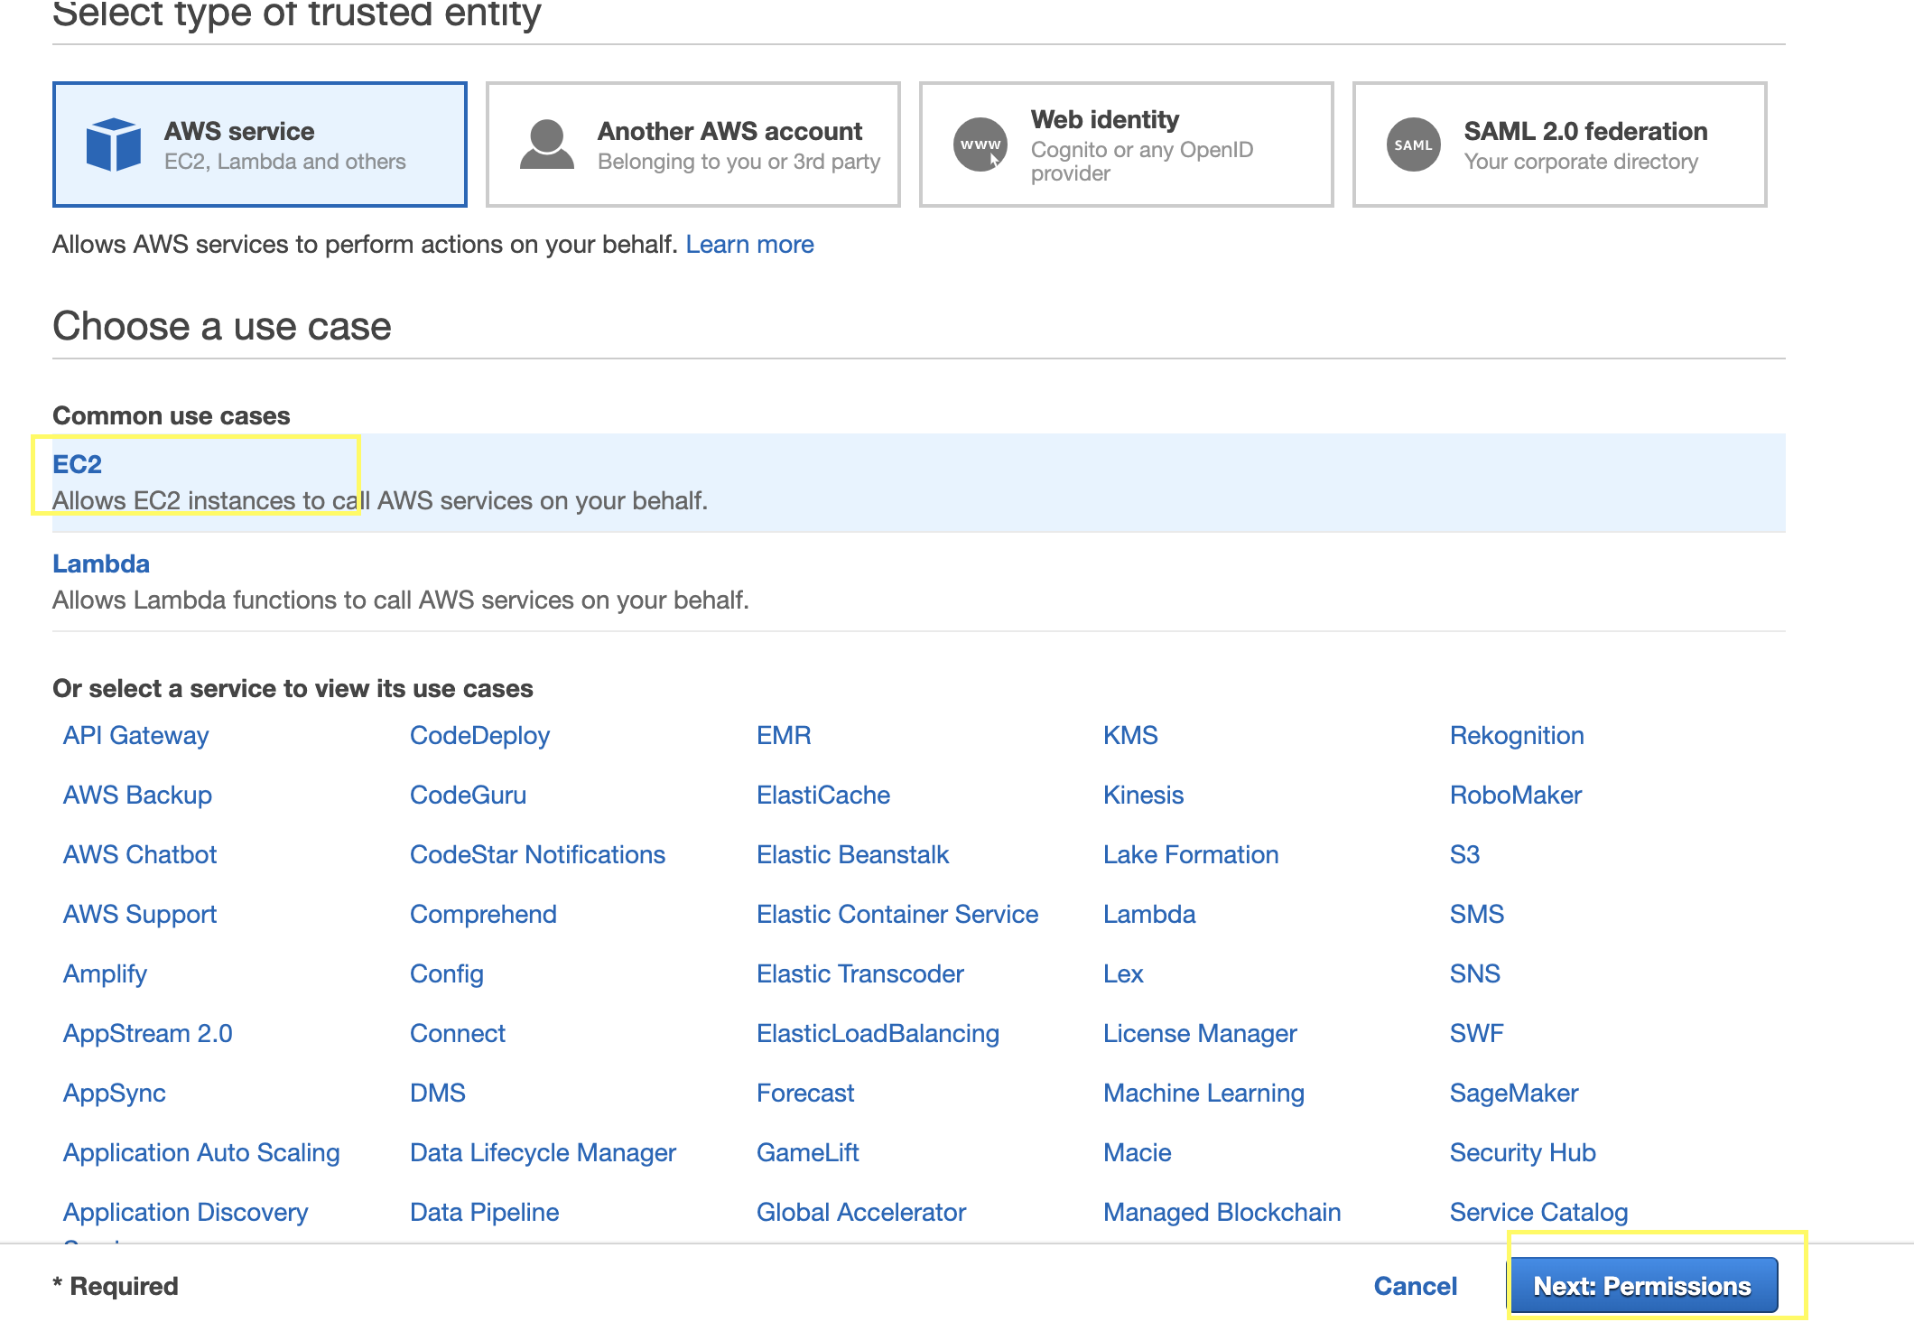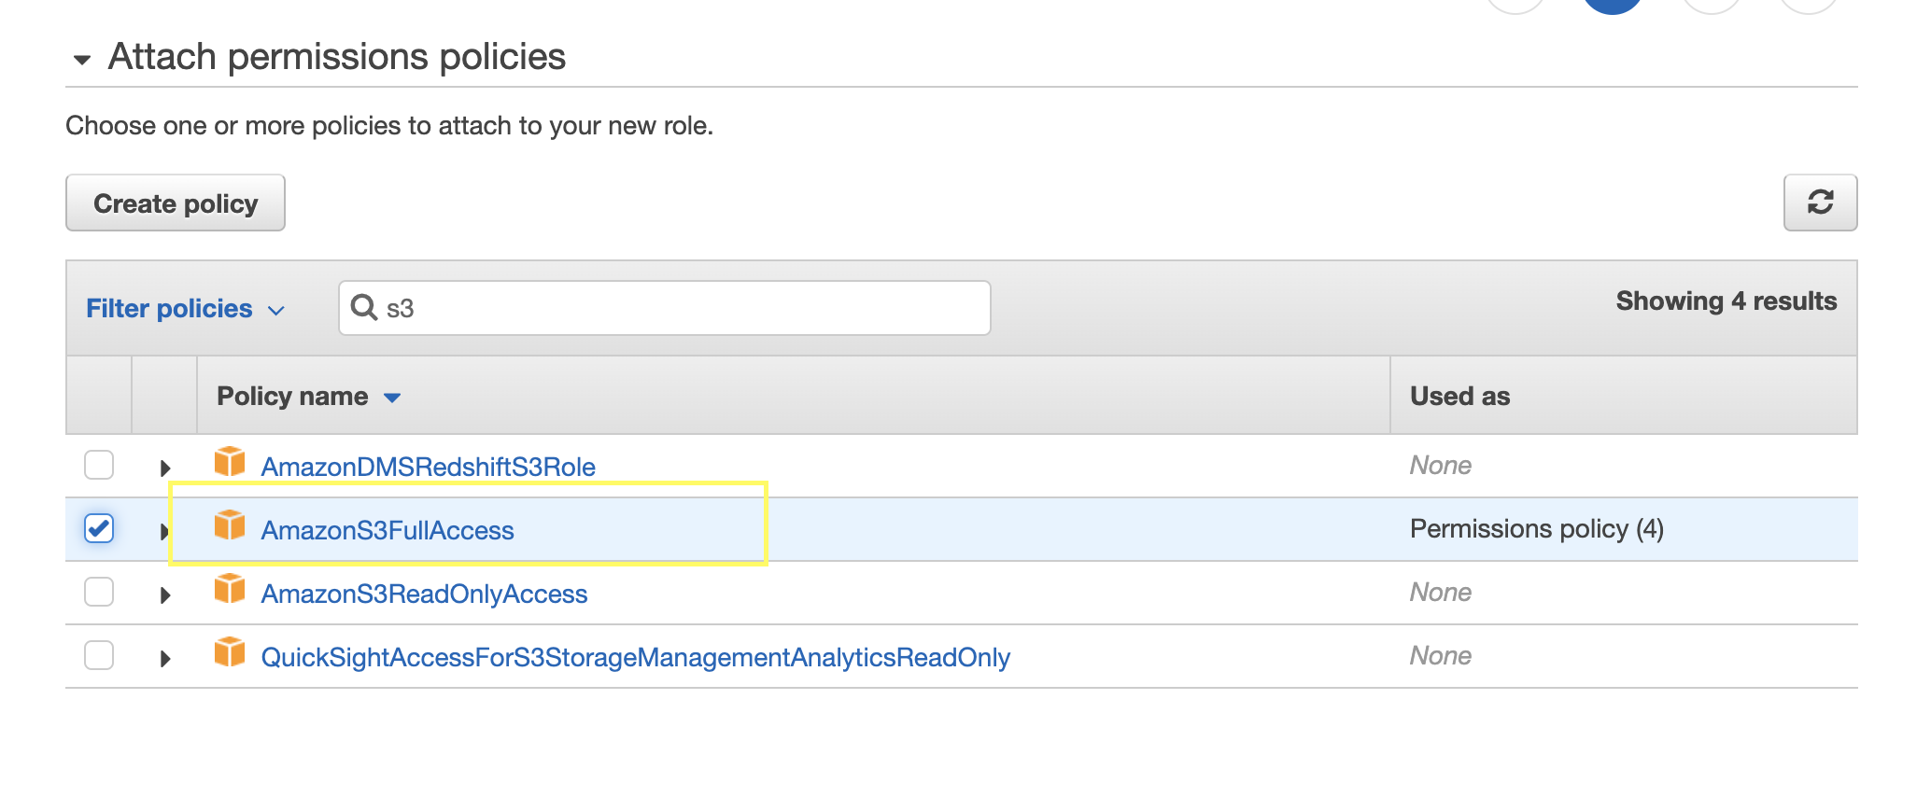

4. Go to EC2 Service and launch new instance

The requirements from our team lead for the EC2 instance:

1. Web Servers to be in London Region
2. Instance type: t2.micro
3. AMI : Amazon Linux 2 AMI (HVM)
4. VPC: default
5. **IAM Role: Choose the role we created earlier**
6. Public IP: enabled
7. **Update the security group to allow HTTP access on port 80**

!!! While Launching the instance in the Configure Instance Details Tab, scroll down and in Advanced Details in User Data enter the following script:

#!/bin/bash

yum update -y

yum install -y httpd.x86_64

systemctl start httpd.service

systemctl enable httpd.service

cd /var/www/html

sudo aws s3 cp s3://penguinbucket2/penguin.jpg penguin.jpg

!!! Exchange **YOURBUCKETNAME** with the name of the bucket your created earlier !!!

5. Launch the instance and Copy the Public DNS(IPv4). You need to send is this address.

6. To test if your solution works, navigate to address and you have to see the web server example page, and if you add to that address “/penguin.jpg” at the end, you should be able to see the picture you stored in S3.

